Ethan James O. Zogg

AJAX notes

* AJAX means Asynchronous JavaScript and XML
* 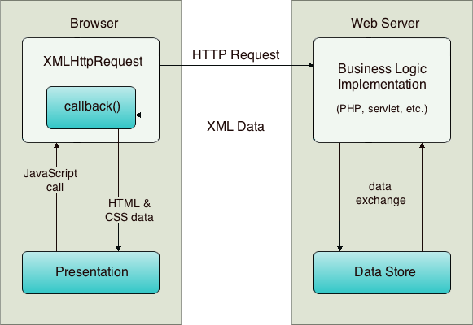

How the diagram works  
The user triggers an event, for example by releasing a key when typing in a name. This results in a JavaScript call to a function that initializes an XMLHttpRequest object.

The XMLHttpRequest object is configured with a request parameter that includes the ID of the component that triggered the event, and any value that the user entered. The XMLHttpRequest object then makes an asynchronous request to the web server.

On the web server, an object such as a servlet or listener handles the request. Data is retrieved from the data store, and a response is prepared containing the data in the form of an XML document.

Finally, the XMLHttpRequest object receives the XML data using a callback function, processes it, and updates the HTML DOM (Document Object Model) to display the page containing the new data.